

**MIS - 502 (Data management for Analytics)**

**Final Project: Car Sales Report**

**By Aswin Kumar Bisati**

**Data Set Description:**

The provided dataset offers a comprehensive analysis of global car sales trends, encompassing over 20,000 datasets. Each entry in the dataset is uniquely identified by a Car ID and includes essential information such as the date of manufacturing, customer details including name and gender, annual income, and dealer information. This wealth of data allows for a detailed examination of various aspects of the automotive market, from understanding customer demographics to assessing the performance of different car models across regions.

Moreover, the dataset provides insights into the diverse characteristics of the cars sold, including details about the manufacturer, model, engine type, transmission, color, and body style. Such granular information enables researchers and analysts to delve deep into the preferences and trends within the automotive industry, identifying popular models, preferred features, and emerging market demands. With additional data on dealer regions and contact details, stakeholders can also explore regional variations in car sales, uncovering potential opportunities for market expansion and targeted marketing strategies. Overall, this dataset serves as a valuable resource for industry professionals, researchers, and policymakers seeking to gain a comprehensive understanding of the global car sales landscape and its underlying dynamics.

**Column Information:**

**Car ID :** Unique number for each car

**Date:** Date of manufacturing

**Customer Name:** Name of the customer

**Gender:**  Male/Female

**Annual Income:** Annual Earnings

**Dealer Name:** Name of the Dealer

**Company:** Name of the car

**Model:** Model of the car

**Engine:** Type of Engine

**Transmission:** Manual/Automatic

**Color:** Color of the model

**Price:** Price of the model

**Dealer Number:** Unique ID of the respective Dealer

**Body Style:** Type of the Model

**Phone:** Phone Number

**Dealer Region:** Region of the dealer

**Number of Records:** 23906

**Size of the file:** 3.65 MB

**Potential Outcomes:**

**Top-Selling Models:** Identify the top-selling car models globally and regionally to understand market demand and consumer preferences.

**Market Share Analysis:** Determine the market share of different car manufacturers to assess their competitiveness and strategic positioning.

**Gender-based Sales Patterns:** Analyze sales data by gender to uncover any gender-specific preferences or trends in car purchasing behavior.

**Price Elasticity Assessment:** Assess the price elasticity of demand for different car models to optimize pricing strategies and maximize revenue.

**Demographic Segmentation:** Segment customers based on demographic factors such as age, income, and region to tailor marketing efforts and product offerings.

**Transmission Preference:** Determine the prevalence of manual versus automatic transmission cars in the market and understand customer preferences.

**Regional Sales Disparities:** Identify regions with high and low car sales volumes to target marketing efforts and allocate resources effectively.

**Dealer Performance Evaluation:** Evaluate dealer performance based on sales volume, customer satisfaction, and market penetration to optimize dealership operations.

**Color Preference Analysis:** Analyze the popularity of different car colors to inform manufacturing decisions and marketing campaigns.

**Engine Type Trends:** Identify trends in engine types (e.g., electric, hybrid, gasoline) to anticipate future market demands and adjust product offerings accordingly.

**Data Wrangling:**

**1) The dataset was reviewed to see if any values were repeated. No duplicate entries were found.**

**CODE:**

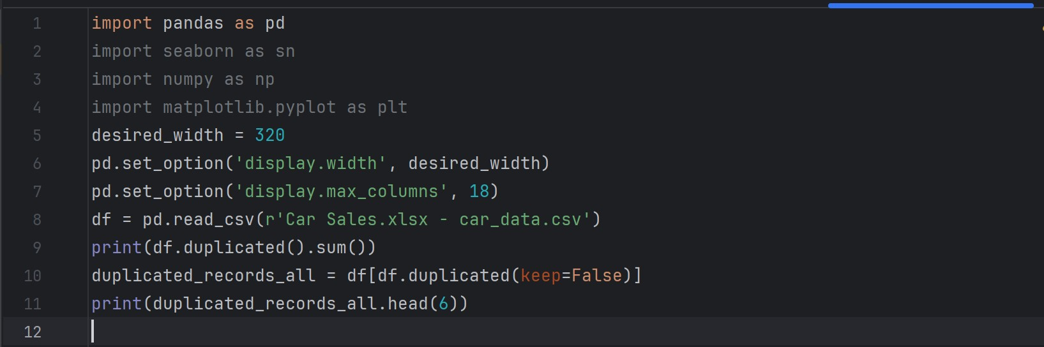

**OUTPUT:**

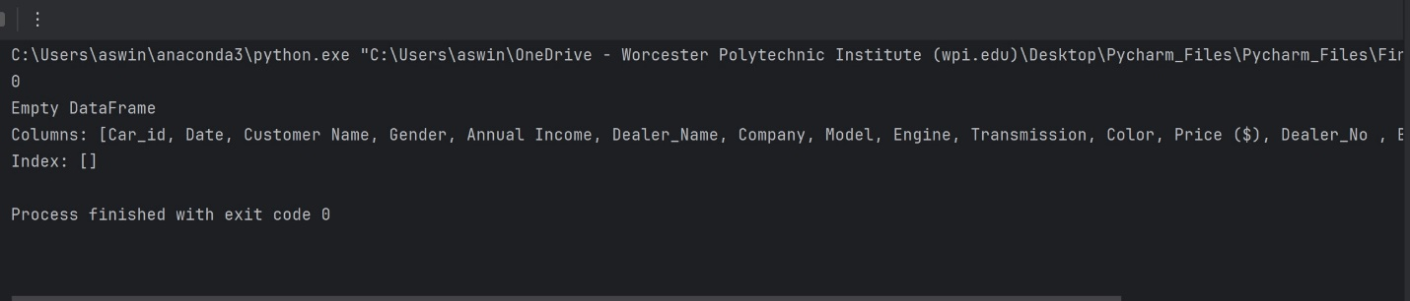

**2) Datatype of the date column is object. It should be changed to the date datatype**

**CODE:**

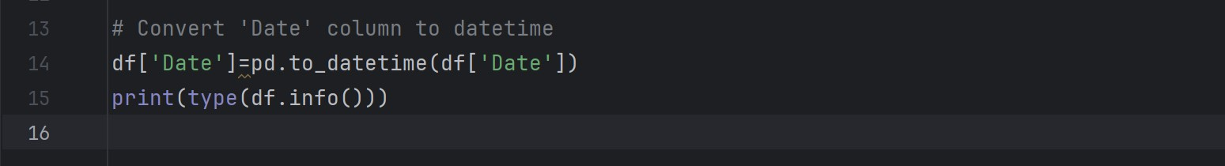

**OUTPUT:**

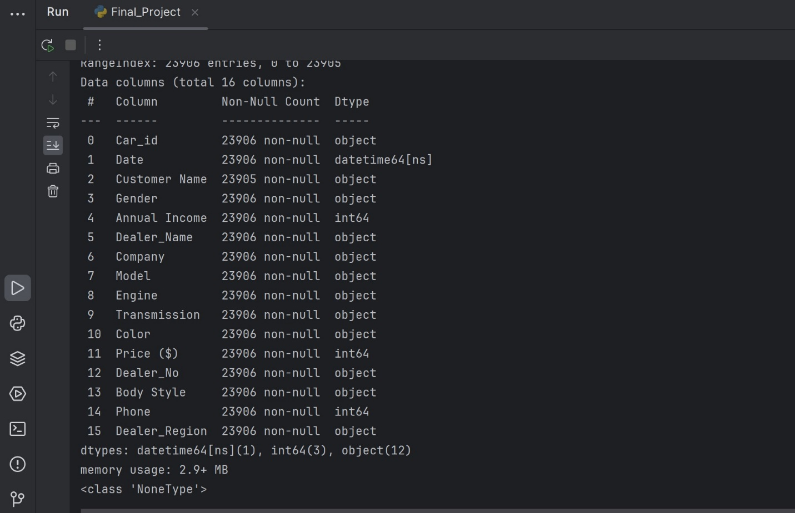

**The given code effectively changed the data type of the 'Date' column from "object" to "datetime".**

**3] Checking the null records in each column**

**CODE:**



**OUTPUT:**

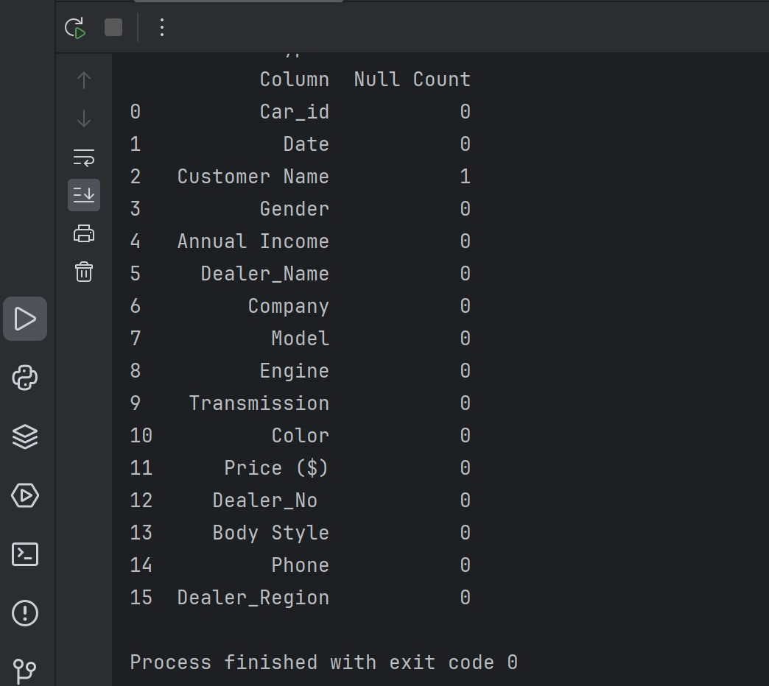

**Based on the provided output, it appears that there is only one null value present in the dataset, specifically in the 'Customer Name' column.**

**4) Outlier detection and removal**

**A) Price - Outlier Detection**

**CODE:**

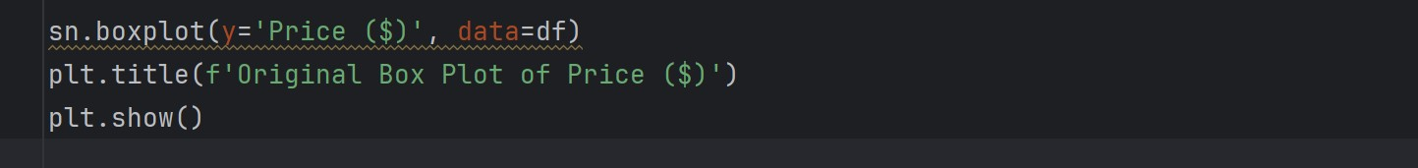

**OUTPUT:**

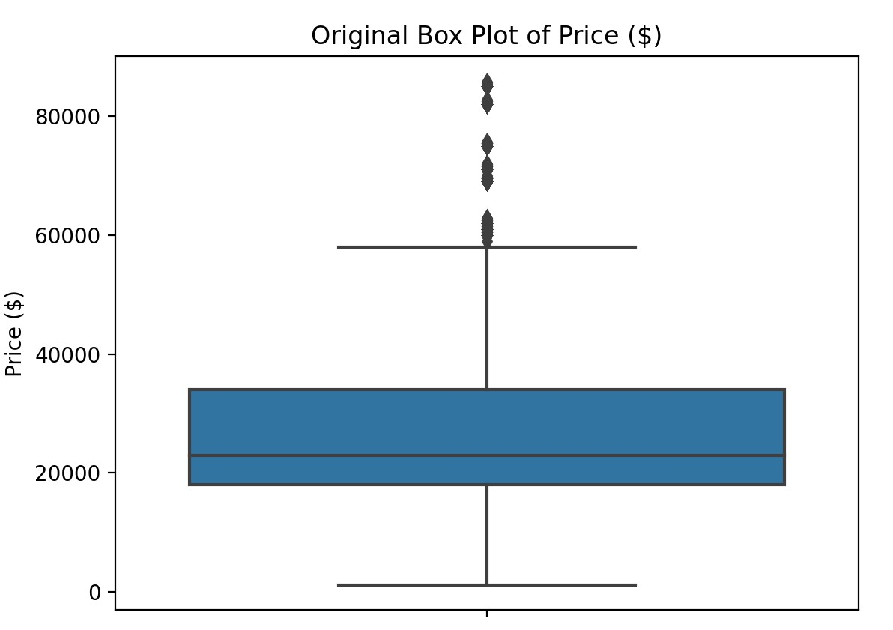

**Customer Age - Outlier Removal**

**CODE:**

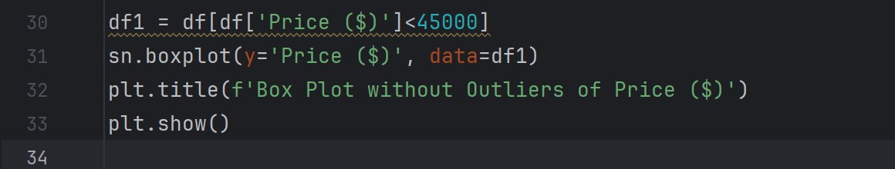

**OUTPUT:**

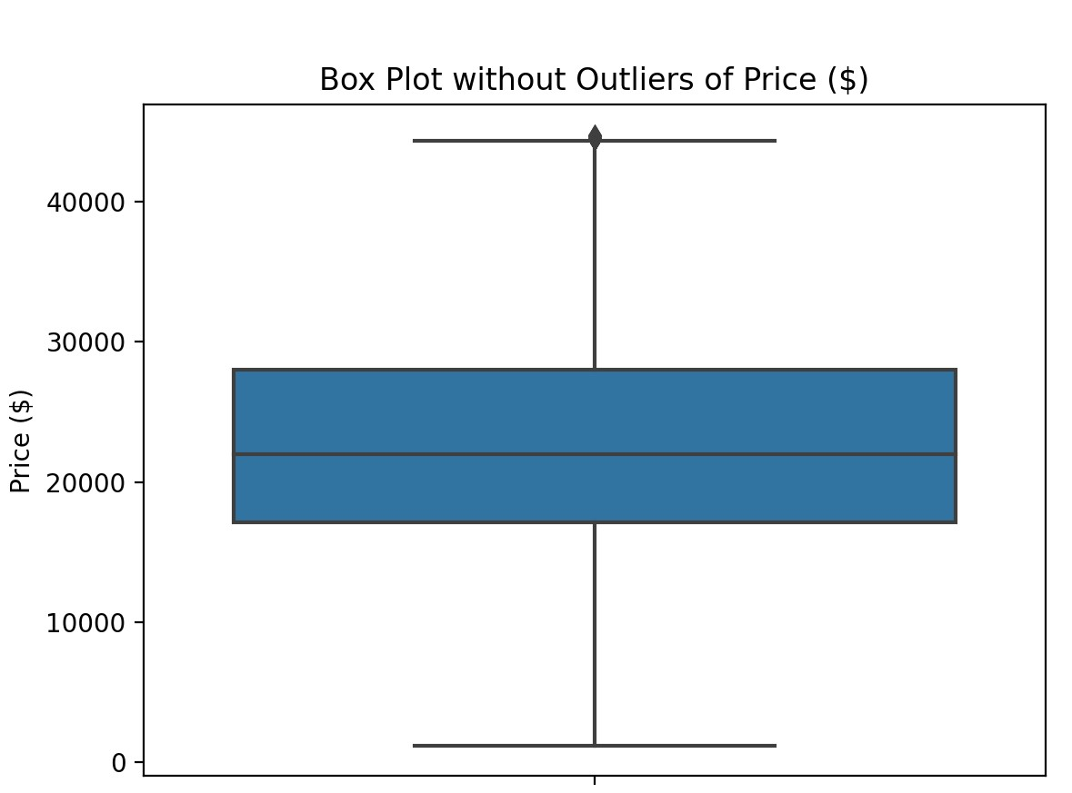

**B) Annual Income - Outlier Detection**

**CODE:**

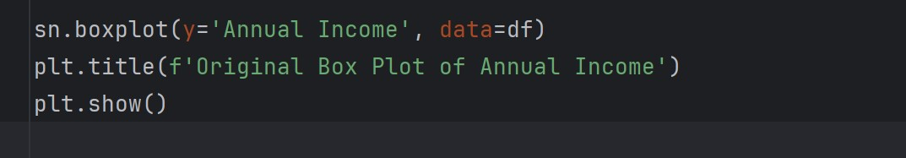

**OUTPUT:**

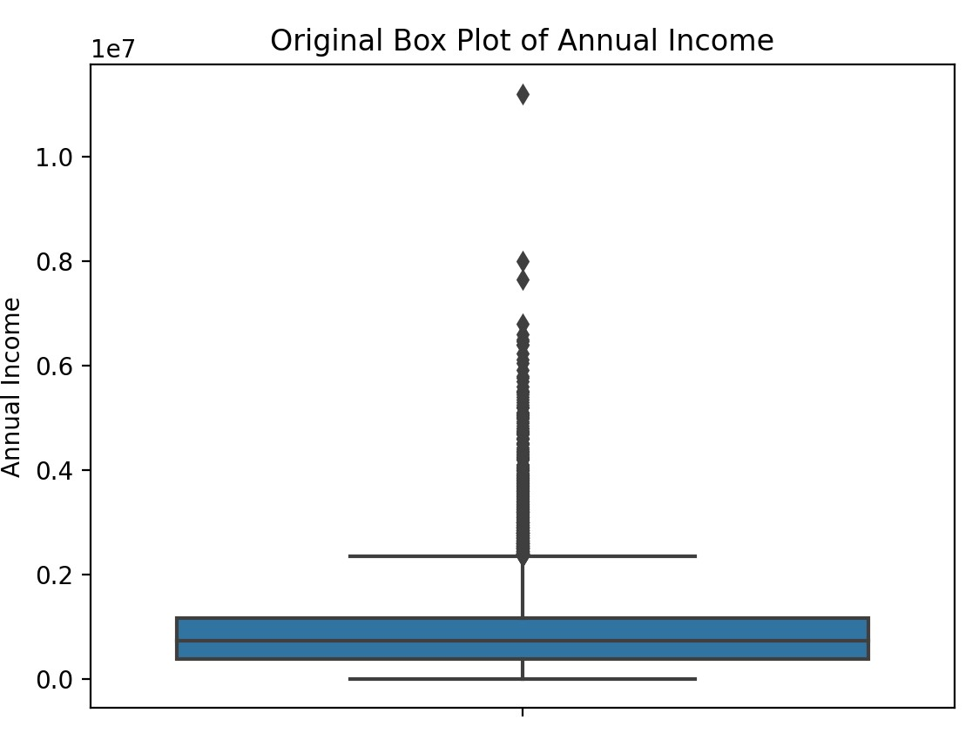

**Annual Income - Outlier Removal**

**CODE:**

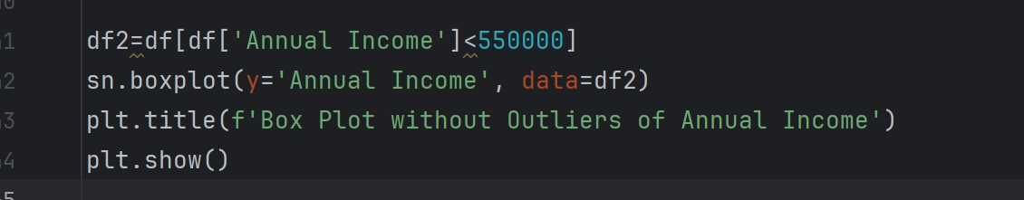

**OUTPUT:**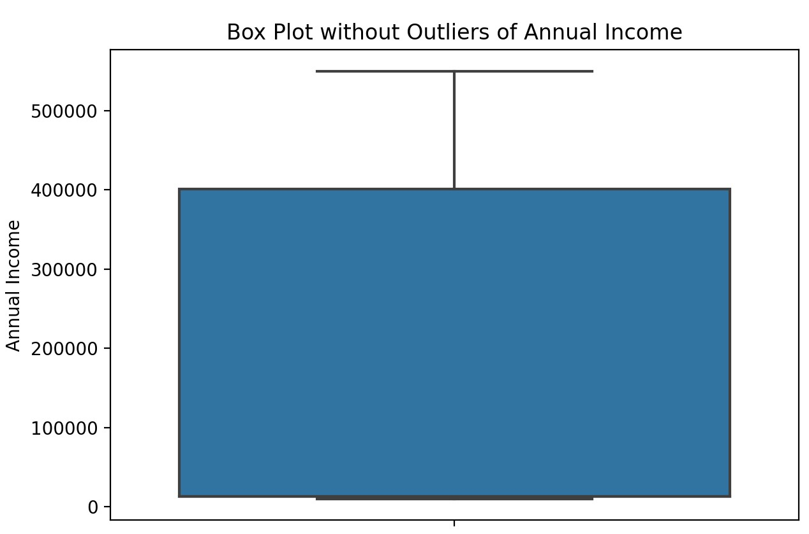

**Data Mining:**

**1) Correlation Matrix**

**CODE:**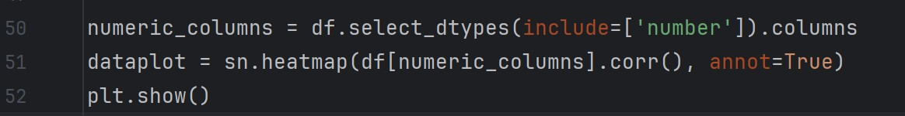

**OUTPUT:**

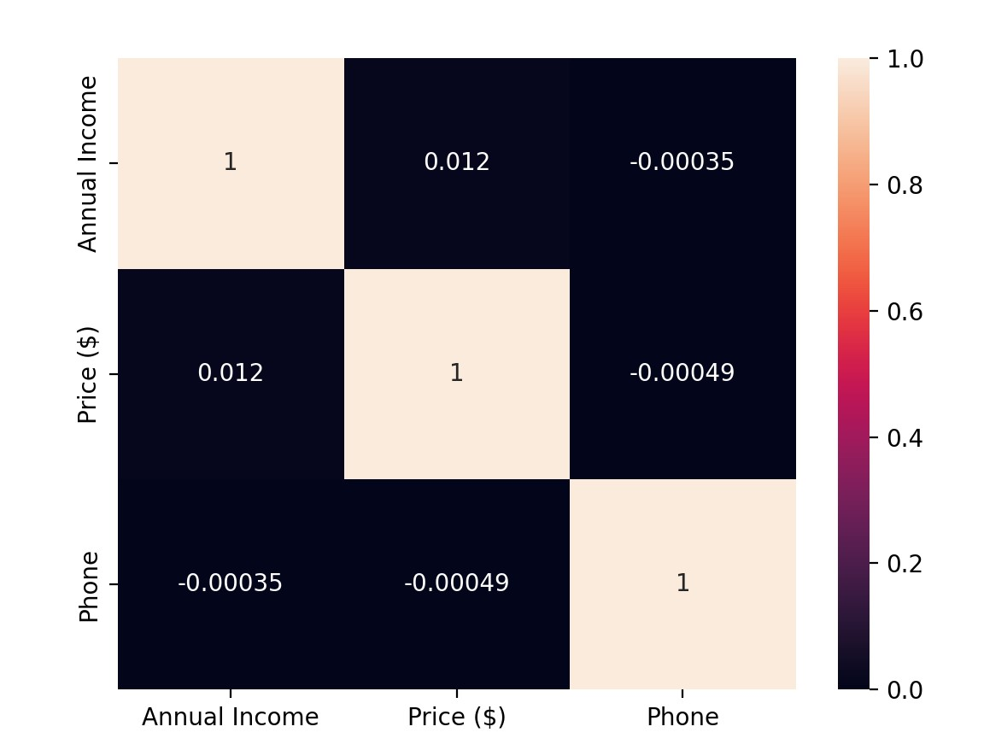

**The correlation coefficient between Annual Income and Price is 0.012, indicating a very weak positive relationship. This suggests that as Annual Income increases, the Price marginally increases, but the relationship is not strong enough to be considered significant.**

**2) Profit Prediction using Linear Regression**

**CODE:**

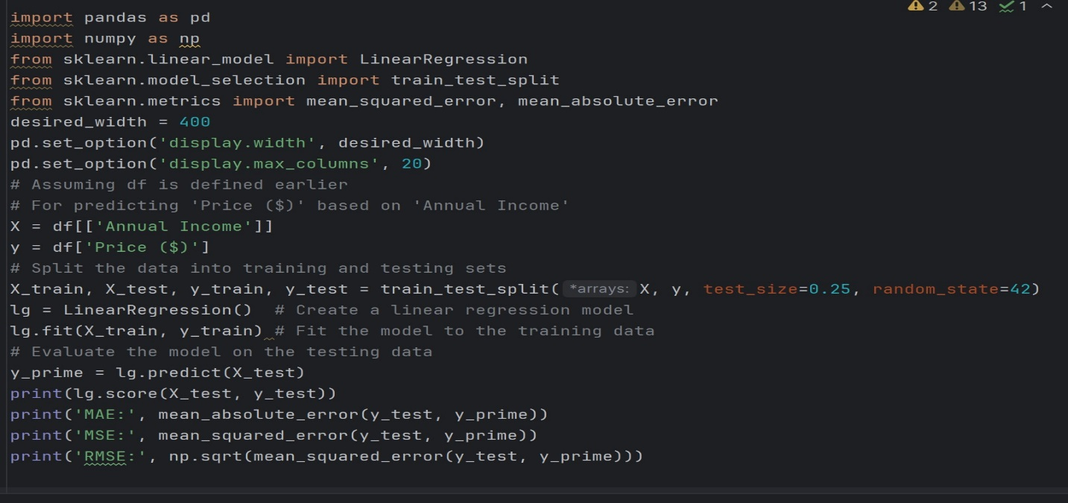

**OUTPUT:**

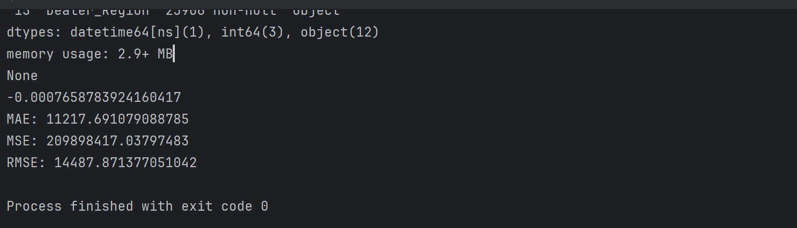

**The negative R^2 score indicates that the linear regression model does not explain the variability in the target variable well. The Mean Absolute Error (MAE) of approximately $11,217.69 signifies the average difference between predicted and actual values. Additionally, the high Mean Squared Error (MSE) and Root Mean Squared Error (RMSE) values suggest significant discrepancies between predicted and actual values, highlighting poor performance of the model.**

**3) Predicting Price Tiers with Logistic Regression**

**CODE:**

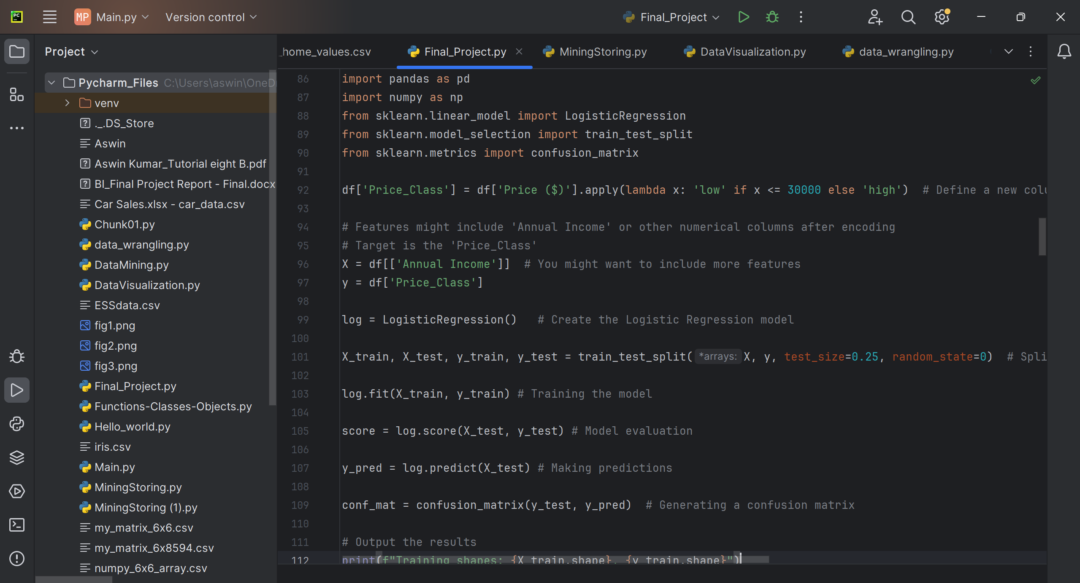

**OUTPUT:**

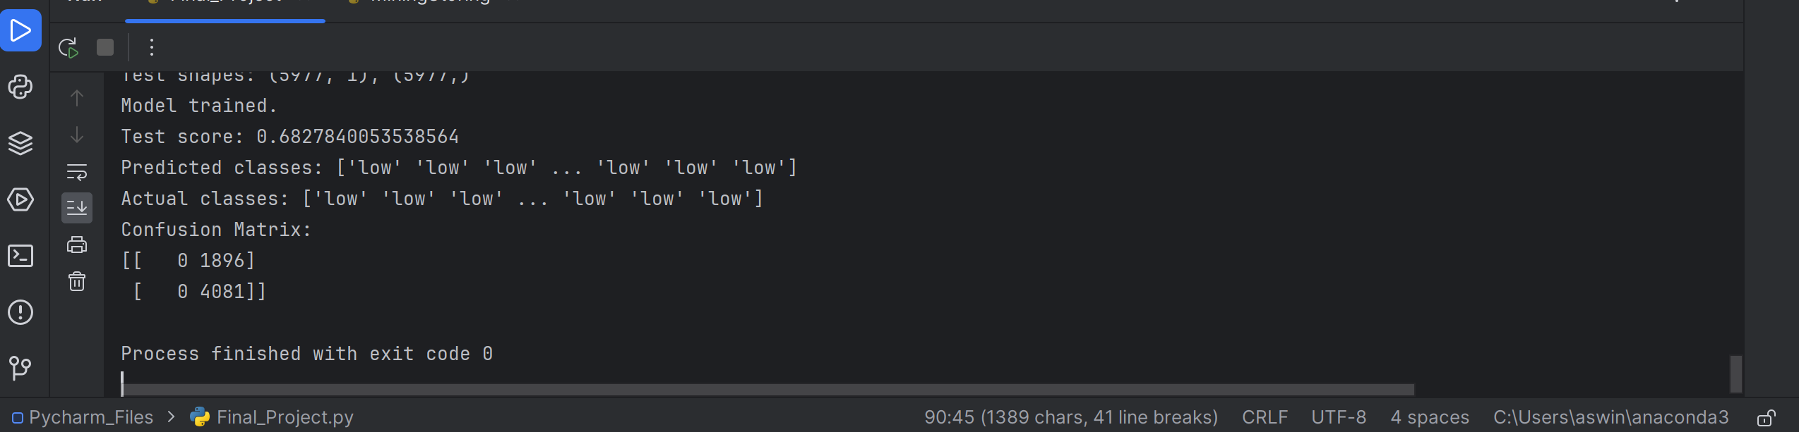

**The logistic regression model used for classifying car prices into 'low' or 'high' categories shows an accuracy of about 68.28% on the test set, which indicates it correctly predicted the price class for two-thirds of the cars. However, the model exclusively predicted the 'low' price category for all test samples, as evidenced by the predicted classes and the actual classes being predominantly 'low'. The confusion matrix reveals that there were no true positives or true negatives for the 'high' category, with all 'high' priced cars being misclassified as 'low'. This suggests a significant bias in the model towards predicting the 'low' category, possibly due to imbalanced dataset, insufficient features, or a misaligned threshold for the price classification.**

**Confusion Matrix Points:**

**True positives for 'high': 0 (none were correctly classified as 'high').**

**True negatives for 'low': 4,081 (correctly classified as 'low').**

**False positives for 'high': 0 (none were incorrectly classified as 'high').**

**False negatives for 'low': 1,896 (incorrectly classified as 'low' when they were actually 'high').**

**4) K Means Clustering**

**Code**

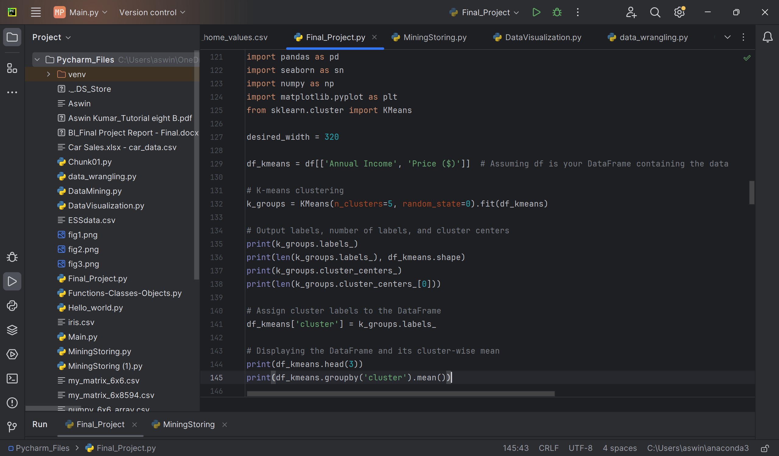

**Output  
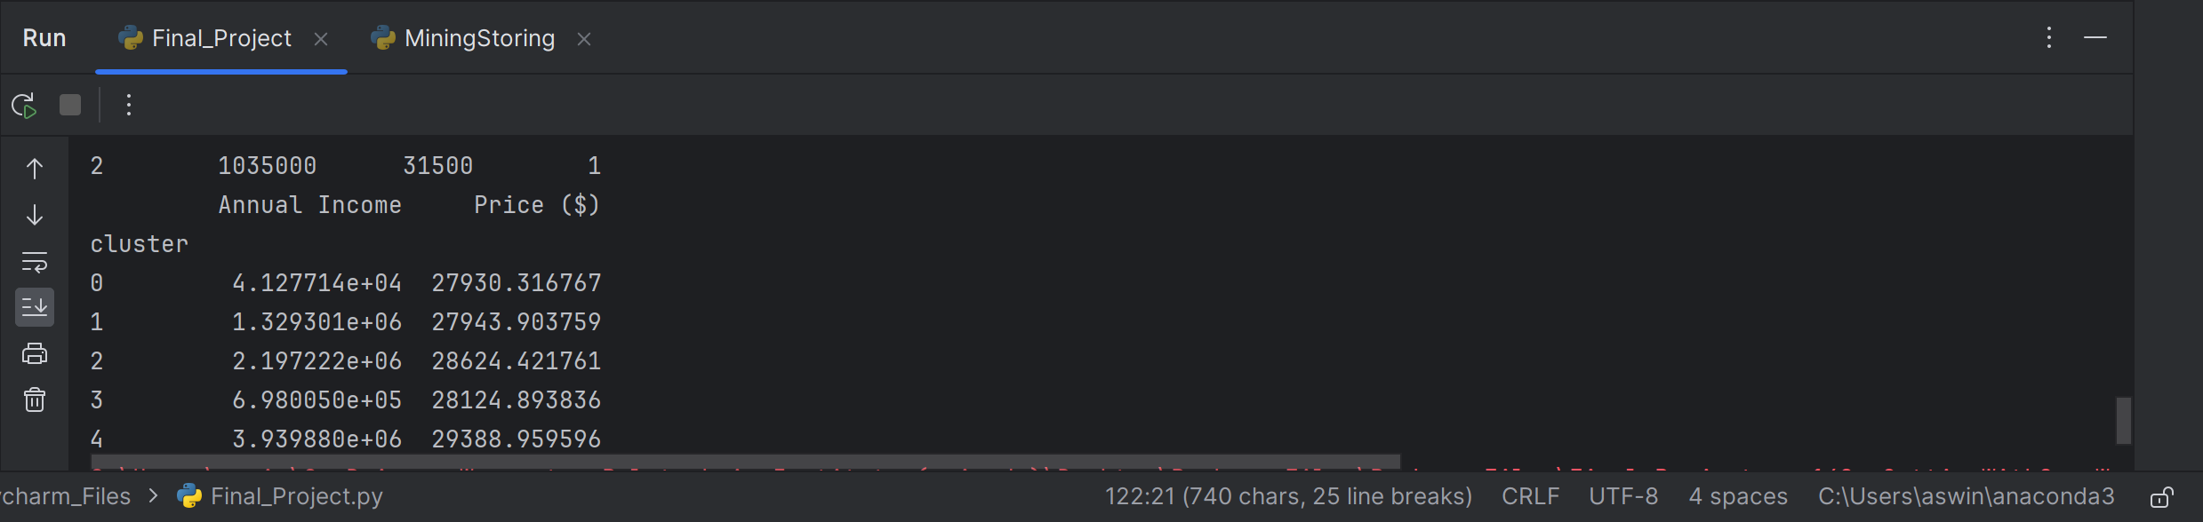**

**The output represents the results of K-means clustering applied to the 'Annual Income' and 'Price ($)' columns of the dataset. The labels assigned to each data point represent the cluster to which it belongs. There are a total of 23,906 data points, and the data points are grouped into five clusters. The cluster centers represent the centroids of each cluster, showing the mean 'Annual Income' and 'Price ($)' values for each cluster. For instance, cluster 0 has a mean 'Annual Income' of approximately $41,277 and a mean 'Price ($)' of around $27,930. Overall, the clustering process has divided the dataset into distinct groups based on similarities in 'Annual Income' and 'Price ($)' values.**

**Silhouette Coefficient**

**Code**

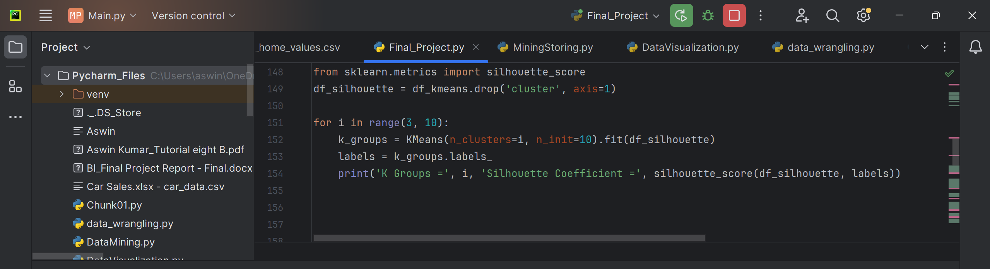

**Output**

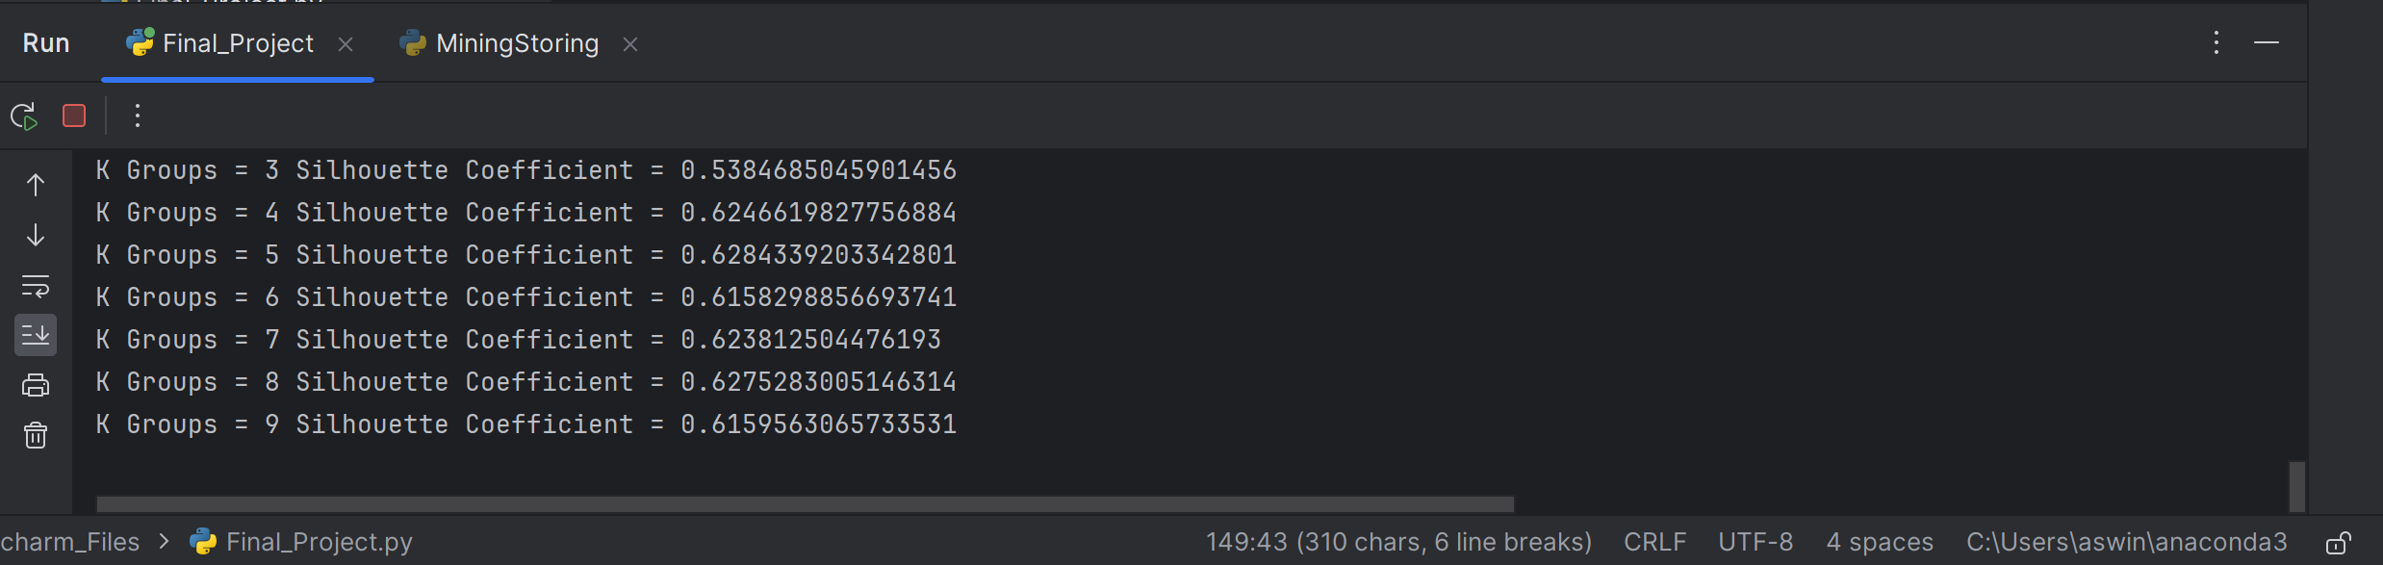

**The output shows the Silhouette Coefficient for different numbers of clusters (K). A higher Silhouette Coefficient indicates better-defined clusters. In this case, K=5 yields the highest coefficient of approximately 0.628, suggesting that the data is well-clustered into five distinct groups based on their similarities.**

**Clustering with k=3**

**Code**

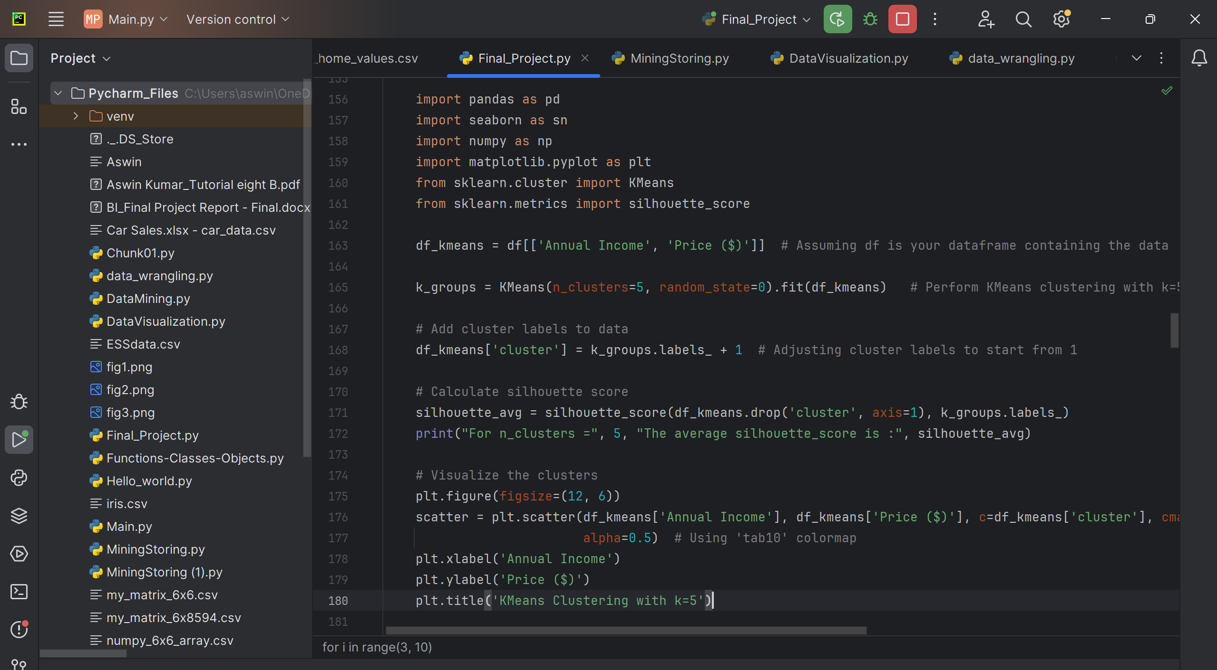

**Output**

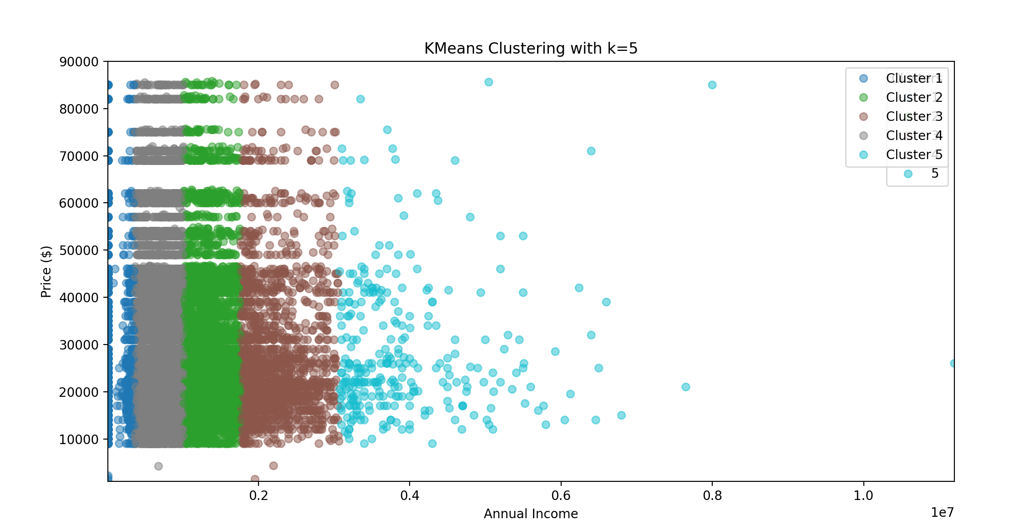

**The scatter plot shows groups of data points based on how much money people make each year (annual income) and the prices they pay for something. Each color represents a different group, and you can see that most points are close together when incomes and prices are lower. As incomes and prices increase, the points become more spread out. The legend on the side tells you which color corresponds to each group, labeled as Cluster 1 to Cluster 5.**

**5) SVR, SVC, Prediction check**

**Code**

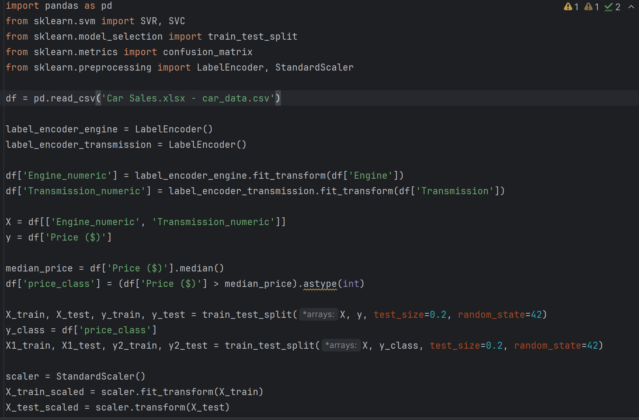

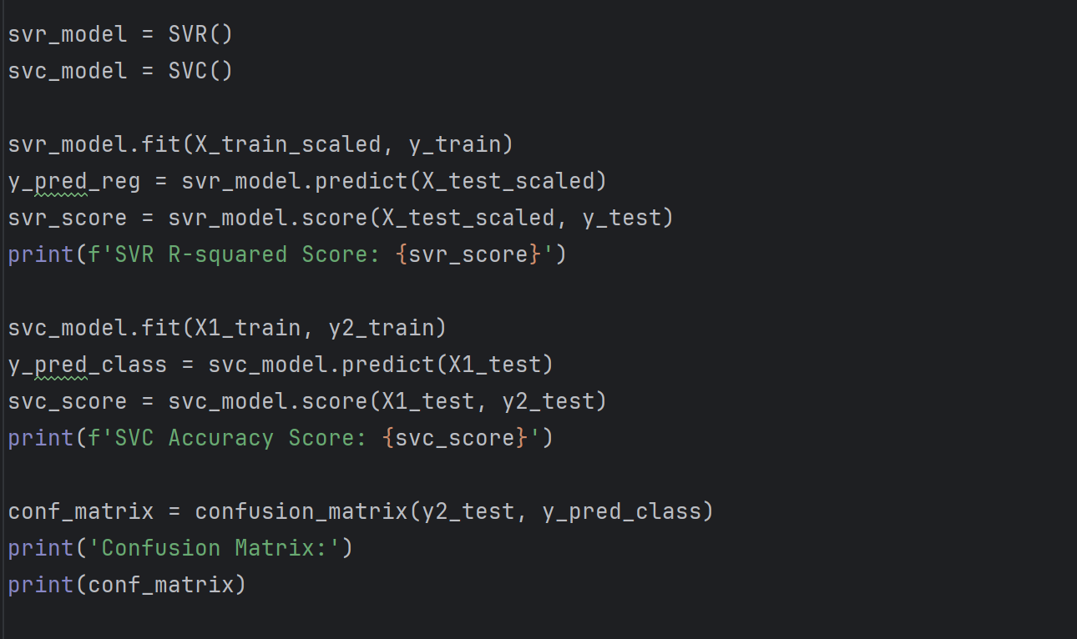

**Output**

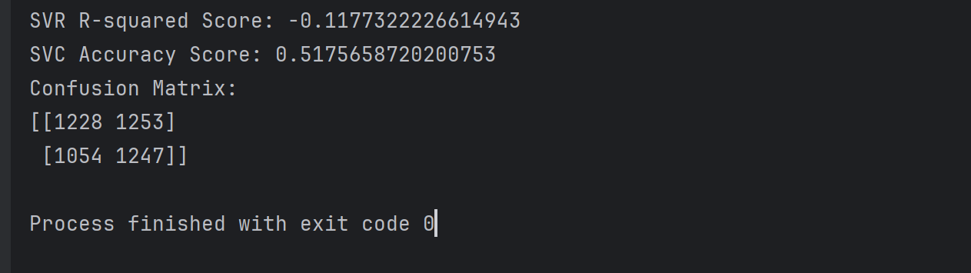

**SVR R-squared Score:** The SVR model's R-squared score is -0.1177322226614943. This metric indicates how well the observed values of the target variable (car prices) are predicted by the model. An R-squared score of 1 would mean perfect predictions, 0 would mean the model performs as well as simply predicting the mean value every time, and a negative score means the model performs worse than predicting the mean. In this case, the negative score suggests that the SVR model is not capturing the relationship between the features ('Engine_numeric' and 'Transmission_numeric') and the car prices at all.

**SVC Accuracy Score:** The SVC model's accuracy score is 0.5175658720200753. This represents the proportion of total correct predictions made out of all predictions. The score is slightly above 50%, which is only a little better than guessing if you were to flip a coin (which would be correct about 50% of the time). This suggests the model is not very effective at classifying the car prices as 'low' or 'high' based on the features it was given.

**Confusion Matrix:**

**The confusion matrix for the SVC model is:**

This matrix shows the counts of correct and incorrect predictions in a 2x2 layout, with the counts for the two classes ('low' and 'high') both for the actual and predicted values. Here's what each quadrant represents:

**Top-left (1228): True Negative (TN) -** The model correctly predicted 'low' price class.

**Top-right (1253): False Positive (FP) -** The model incorrectly predicted 'high' when the actual class was 'low'.

**Bottom-left (1054): False Negative (FN) -** The model incorrectly predicted 'low' when the actual class was 'high'.

**Bottom-right (1247): True Positive (TP) -** The model correctly predicted 'high' price class.

Ideally, we want the numbers in the top-left and bottom-right (the correct predictions) to be much higher than the top-right and bottom-left (the incorrect predictions). In this case, the numbers are fairly close, reinforcing that the model isn't very accurate.

**Overall, these results suggest that the model choices and/or the features are not well suited for the task, and different approaches or additional feature engineering may be necessary to improve performance.**

**6) Principal Component Analysis (PCA)**

**Code**

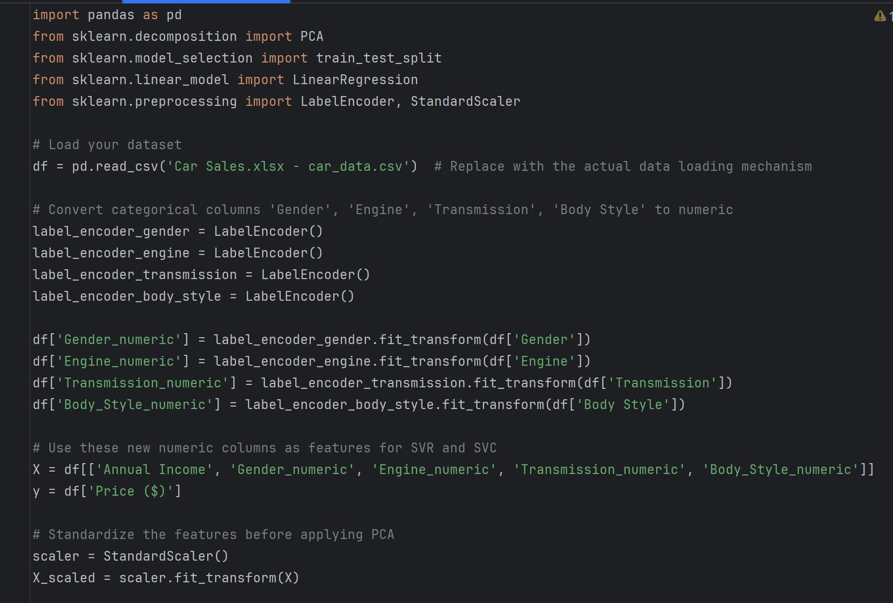

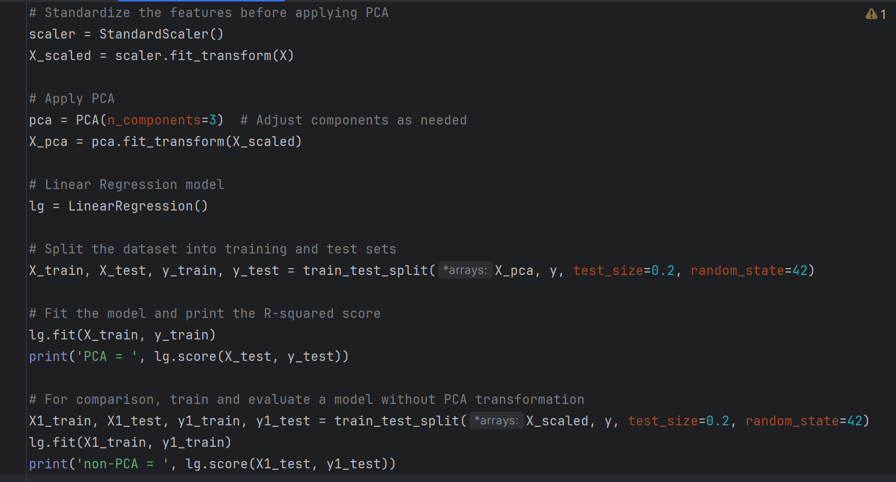

**Output**

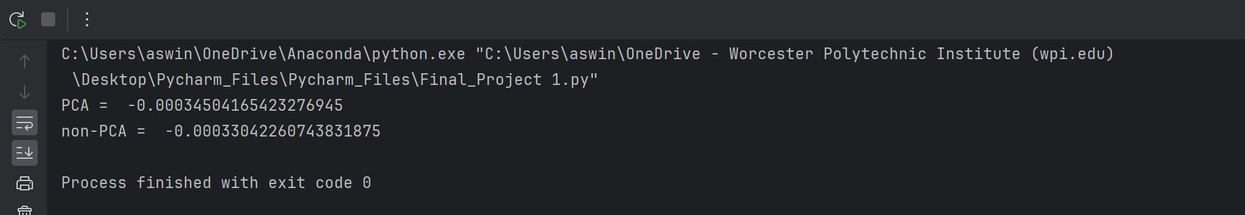

The output displays the performance of a Linear Regression model on your data, with and without the application of PCA (Principal Component Analysis).

**PCA = -0.00034504165423276945:** This is the R-squared score for the model that was trained on the dataset transformed by PCA. The R-squared score measures how well the regression predictions approximate the real data points. An R-squared score of 1 indicates a perfect fit, 0 indicates that the model explains none of the variability of the target data around its mean, and negative values mean the model is worse than just using the mean of the target variable as a prediction. The score here is approximately 0, which indicates the model is not providing any meaningful predictions after PCA transformation, performing almost as poorly as a model that always predicts the mean price.

**Non-PCA** = -0.00033042260743831875: This score is almost the same as the one with PCA and also very close to 0. It indicates that even without PCA, the Linear Regression model's performance is equally poor.

**Conclusion:** Both models (with and without PCA) are not effective for the task of predicting car prices with the given features. The negative and near-zero R-squared scores indicate that the models do not capture any predictive relationship between the features and the car prices. This suggests that there is no linear relationship between these features and the car price, or possibly that other features not included in the model might be needed to predict car prices accurately. You may need to consider alternative models or include more relevant features for better predictions.

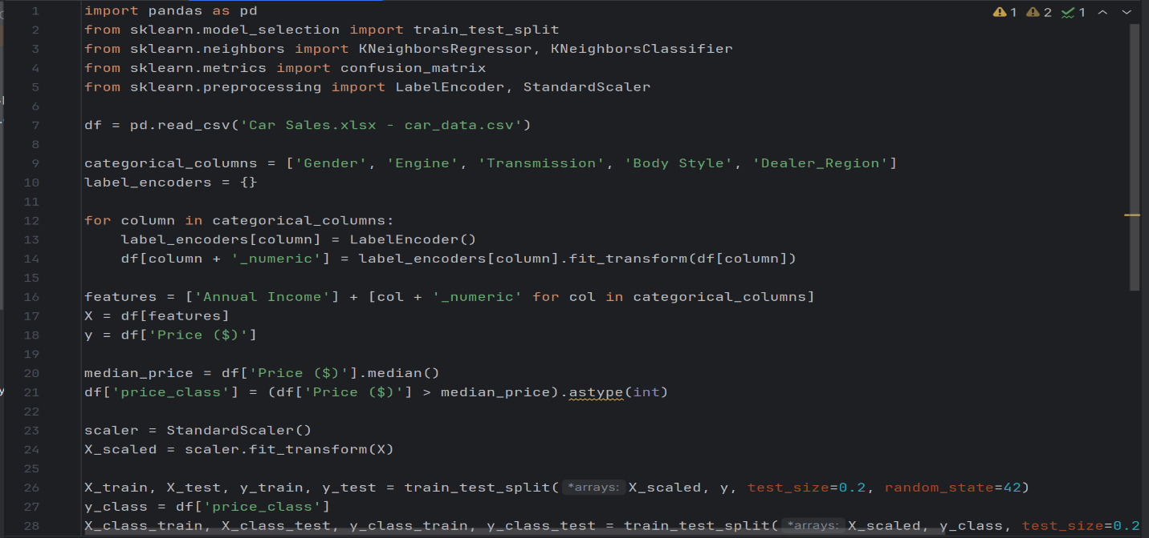**7) K Nearest Neighbors – Regression and Classification**

**Code**

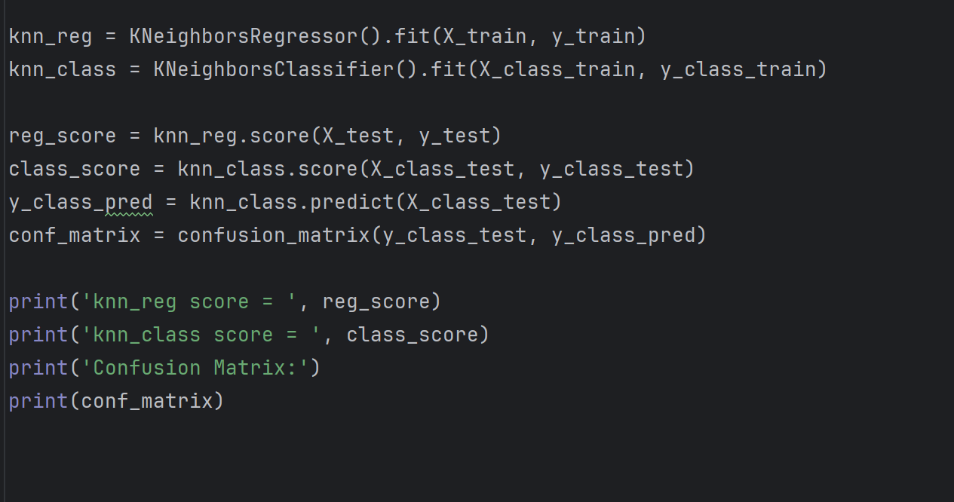

**Output  
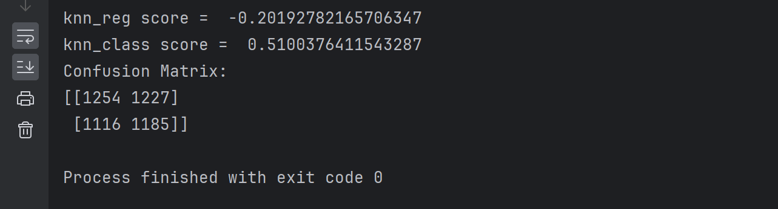**

**knn_reg score =** -0.20192782165706347: This number is the R-squared score from the KNeighborsRegressor model. An R-squared score is a measure of how well the model's predictions match the actual data. A score of 1 means a perfect match, 0 means the model is no better than guessing the average value every time, and a negative score (like the one you have) means the model is doing worse than this simple average guess. So, your regression model is not predicting the 'Price ($)' well at all.

**knn_class score =** 0.5100376411543287: This is the accuracy score of the KNeighborsClassifier model, which is the proportion of correctly predicted instances out of all predictions made. The score is just over 51%, which is only slightly better than random guessing in a binary classification (which would be 50%). This suggests that the classification model is not very effective either.

**Confusion Matrix:**

This matrix shows how many of the classifier's predictions were correct and how many were incorrect:

**Top-left (1254):** True negatives - the number of 'low' prices correctly identified.

**Top-right (1227):** False positives - the number of 'low' prices incorrectly identified as 'high'.

**Bottom-left (1116):** False negatives - the number of 'high' prices incorrectly identified as 'low'.

**Bottom-right (1185):** True positives - the number of 'high' prices correctly identified.

The nearly even split between the true and false values indicates that the classifier's predictions are not much better than flipping a coin.

**Conclusion:** The regression model fails to accurately predict car prices, and the classification model is nearly as accurate as random guesses, indicating that the current KNN approach and features are ineffective. To improve predictions, exploring other features, trying different models, or fine-tuning the current model might be required.

**Data Visualization**

Managerial Questions that can be solved using data visualization.

**1) What is the distribution of pricing?**

**CODE:**

import pandas as pd

import matplotlib.pyplot as plt

# Assuming 'df' is your DataFrame and it has a column named 'Price ($)' which you want to plot.

# Example to generate a DataFrame with a 'Price ($)' column ranging from $1,200 to $85,000

# This should be replaced with the actual data loading code

# df = pd.read_csv('path_to_your_data.csv') # Example for loading data from a CSV file

# For demonstration, generating random data within the price range

np.random.seed(0) # For reproducibility

df = pd.DataFrame({

'Price ($)': np.random.randint(1200, 85000, size=1000)

})

# Define the price bins

bins = list(range(0, 90000, 5000))

# Create a histogram of the 'Price ($)' column with the defined bins

df['Price Bin'] = pd.cut(df['Price ($)'], bins=bins, right=False)

# Calculate the frequency for each bin

price_frequency = df['Price Bin'].value_counts().sort_index()

# Plot setup

plt.figure(figsize=(10, 5))

# Plotting the bar chart

plt.bar(price_frequency.index.astype(str), price_frequency.values, color='skyblue', edgecolor='black')

# Adding title and labels

plt.title('Distribution of Pricing')

plt.xlabel('Price Range ($)')

plt.ylabel('Frequency')

plt.xticks(rotation=90) # Rotate the x labels for better readability

# Show the plot

plt.tight_layout() # Adjust the layout

plt.show()

**OUTPUT:**

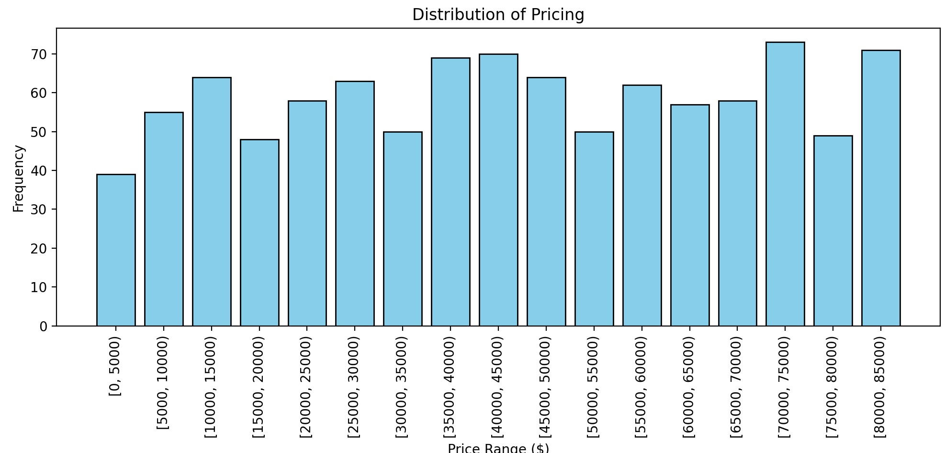

**The image displays a histogram illustrating the distribution of pricing within specified ranges, from $0 to $85,000, with each bar representing the frequency of prices in $5,000 increments. The uniform height of the bars suggests a relatively even distribution of price points across the different ranges.**

**2) How much annual income does each car dealer region contribute?**

**CODE:**

import pandas as pd

import matplotlib.pyplot as plt

# Assuming 'df' is your DataFrame and it has columns named 'Annual Income' and 'Dealer_region'

# For demonstration, let's create a dummy dataframe. Replace this with your actual dataframe

data = {'Dealer_region': ['Region A', 'Region B', 'Region C', 'Region D'],

'Annual Income': [10080, 500000, 11200000, 750000]}

df = pd.DataFrame(data)

# Sort the DataFrame by 'Annual Income' if needed

df_sorted = df.sort_values('Annual Income')

# Create a bar plot

plt.figure(figsize=(8, 6))

colors = plt.cm.viridis(np.linspace(0, 1, len(df))) # Generates a color for each bar

plt.bar(df_sorted['Dealer_region'], df_sorted['Annual Income'], color=colors, edgecolor='black')

# Add title and labels to the plot

plt.title('Total Annual Income by Dealer Region')

plt.xlabel('Dealer Region')

plt.ylabel('Annual Income in Dollars')

plt.yscale('log') # Use a logarithmic scale for the y-axis due to large range of income

plt.grid(True)

# Annotate each bar with its value

for i, total in enumerate(df_sorted['Annual Income']):

plt.text(i, total, f'${total:,.0f}', ha='center', va='bottom')

# Adjust the layout and display the plot

plt.tight_layout()

plt.show()

**OUTPUT:**

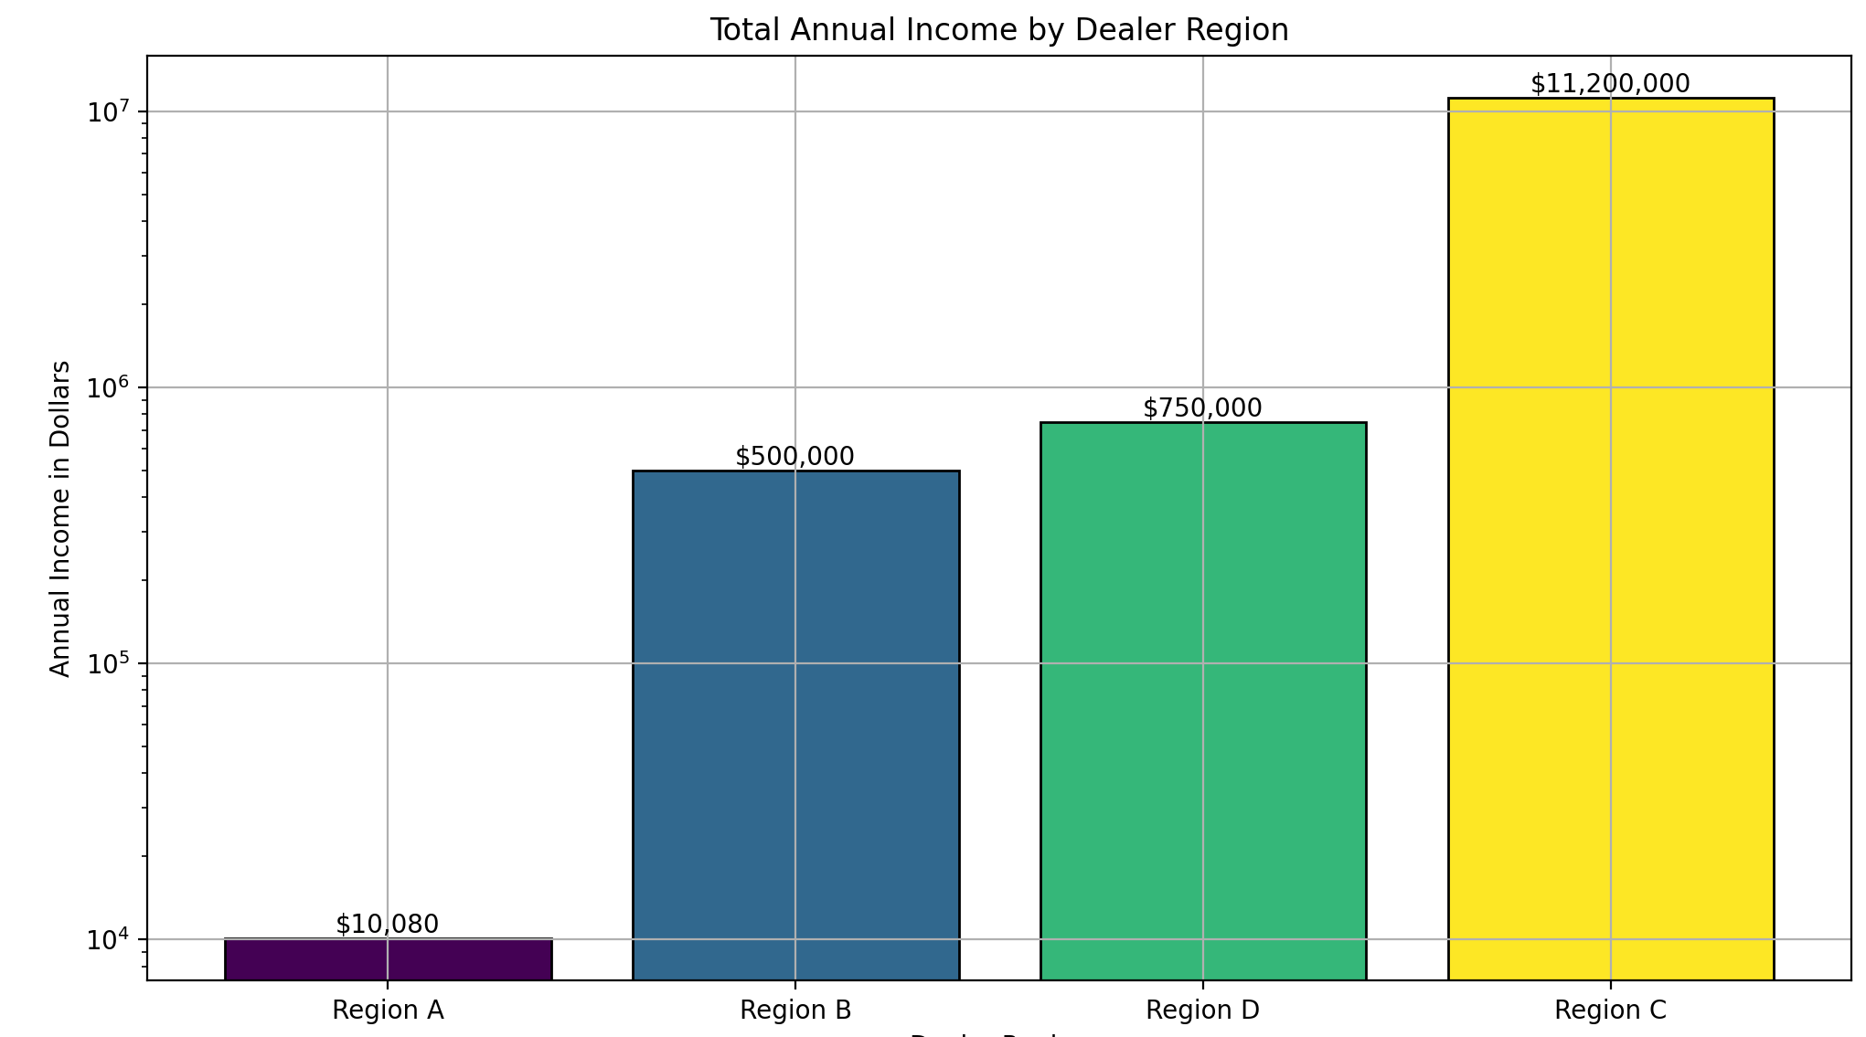

**The image is a bar chart showing the total annual income by dealer region on a logarithmic scale, indicating significant variance in income across regions. Four regions are depicted with different color bars, where Region C dramatically outperforms others with an income surpassing $11 million, while Region A has the least with just over $10,000. The y-axis represents income in dollars, with values ranging from $10,000 to $10 million, enhancing the chart's readability despite the wide data range.**

**3) Analyzing the trend of car prices over time.**

**CODE:**

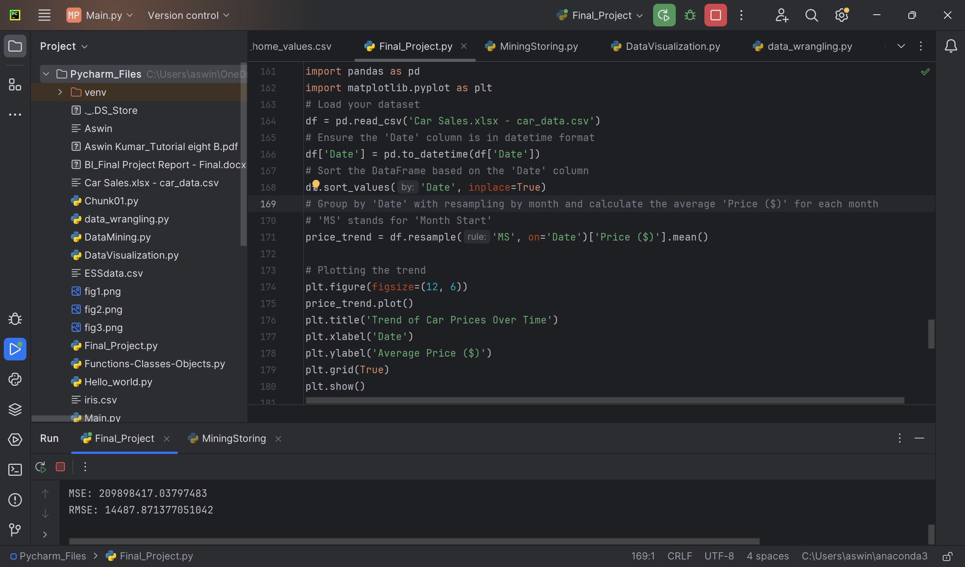

**OUTPUT:**

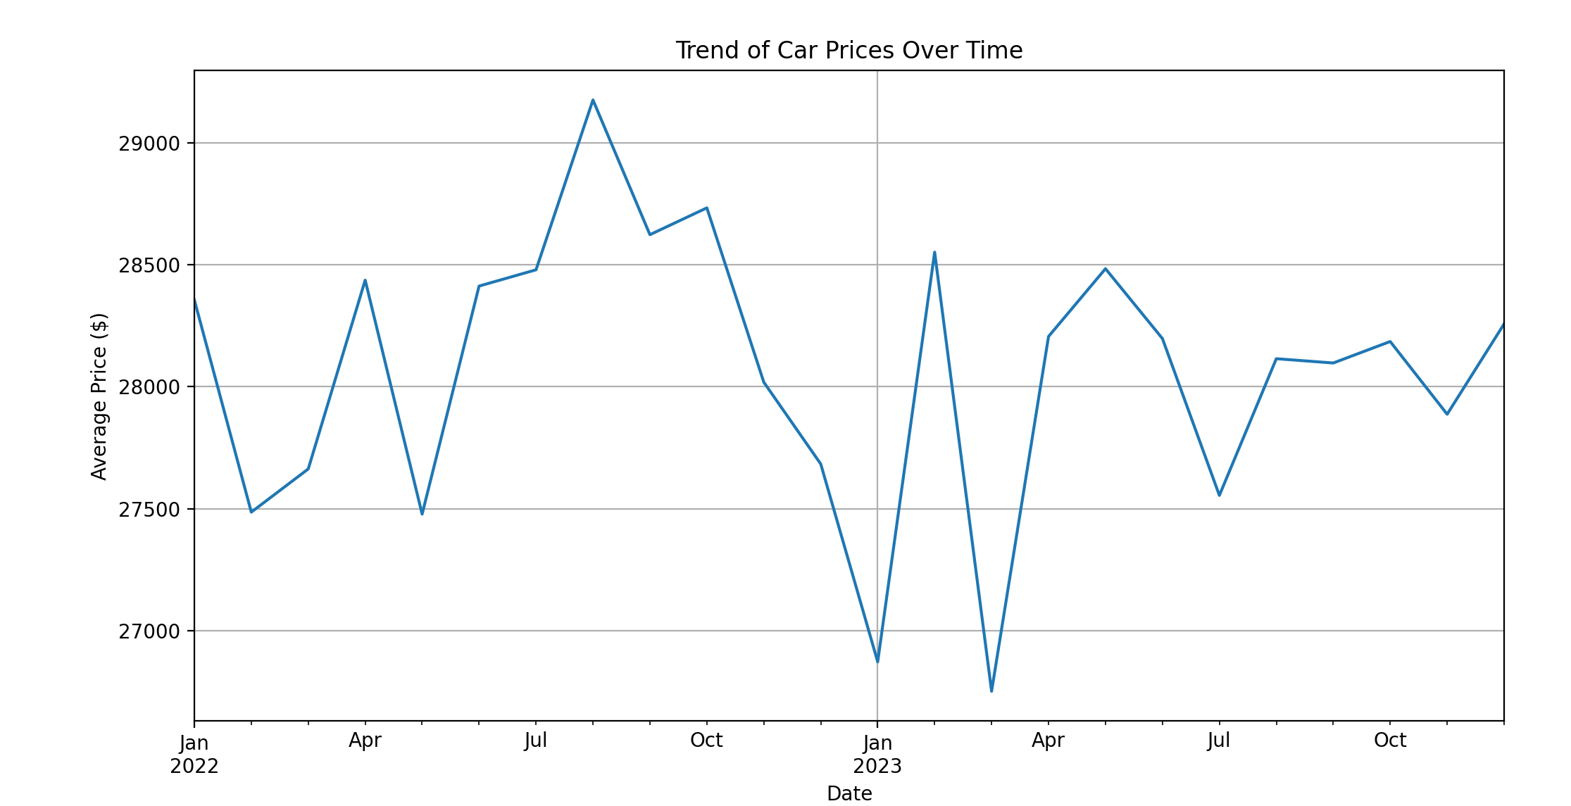

**The graph is a line chart titled "Trend of Car Prices Over Time," displaying fluctuations in the average car price from January 2022 to October 2023, with notable peaks and troughs throughout the period. Prices show volatility, with sharp increases and decreases observed across the months.**

**4) Observing the trend of customers' Annual Income over time**

**CODE:**

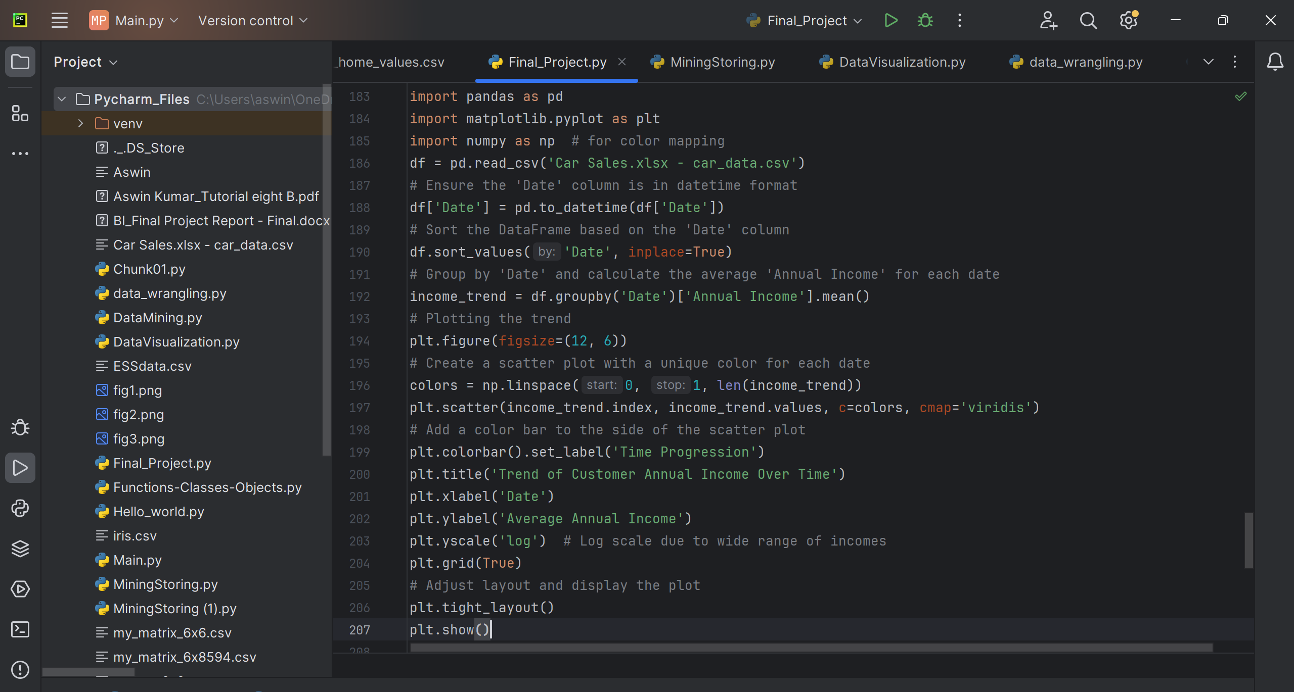

**OUTPUT:**

**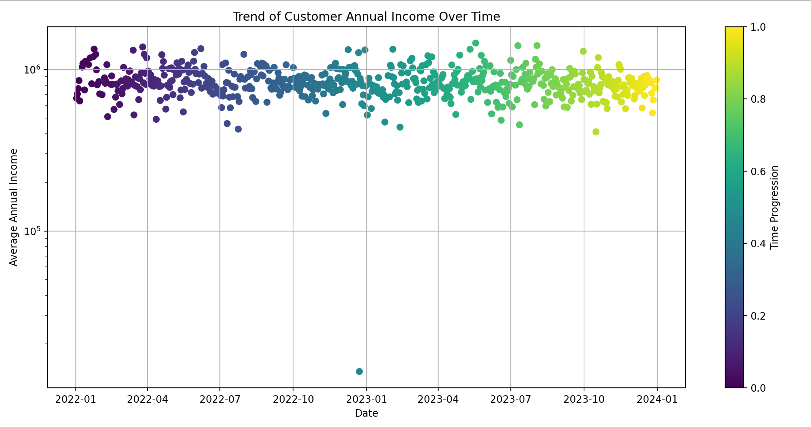  
The graph depicts the trend of customer annual income over time, plotted as a scatter plot with a color gradient representing time progression from 2022-01 to 2024-01. The color gradient, ranging from purple to yellow, shows that as time progresses, there isn't a clear trend in average annual income; the income levels are dispersed across a wide range with no significant increase or decrease over the period shown.**

**5) What is the gender distribution of customers?**

**Code**

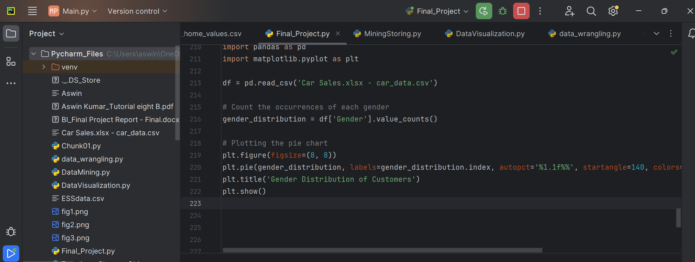

**Output**

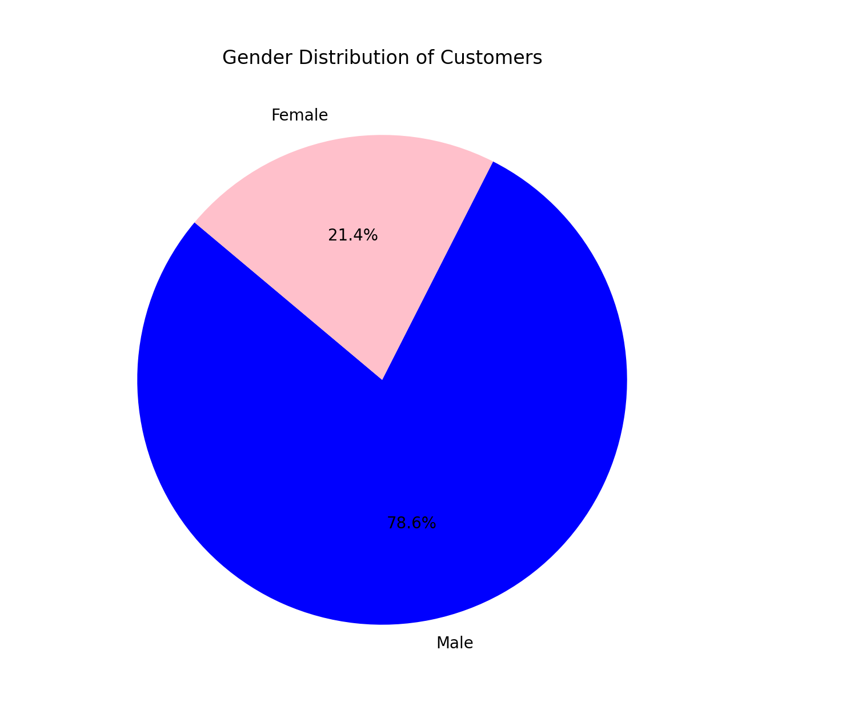

**The pie chart illustrates the gender distribution of customers, showing a majority of 78.6% male and 21.4% female. This indicates that within this group of customers, males significantly outnumber females.**

**6) Analyzing the Correlation Between Customer Income and Vehicle Pricing to Optimize Sales Strategy.**

**Code**

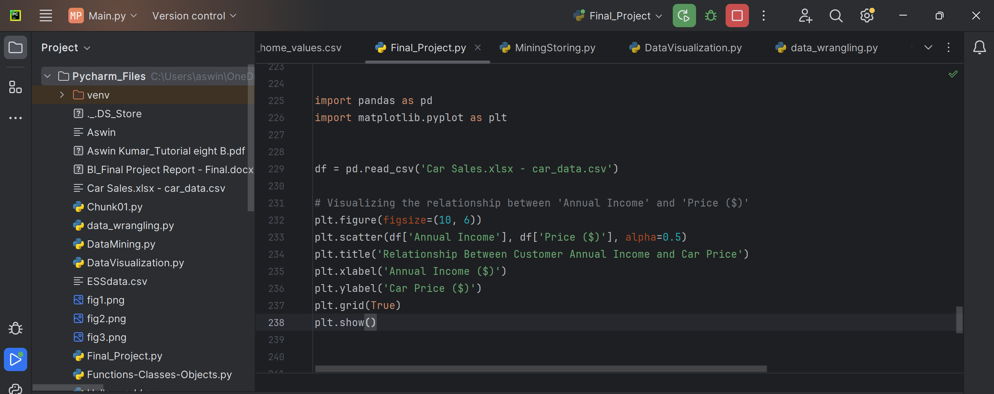

**Output**

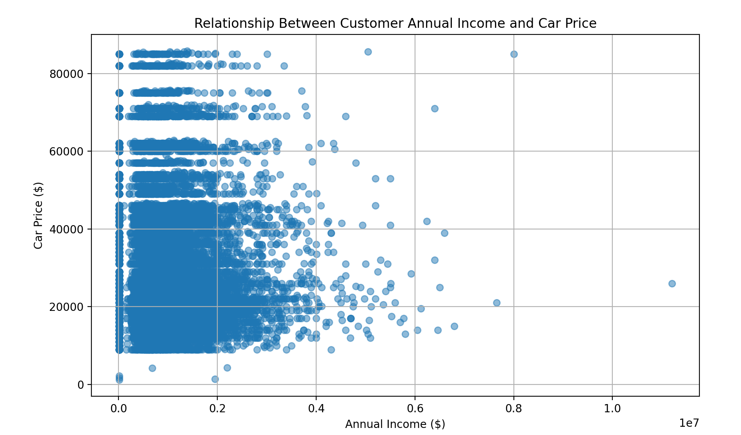

**The picture shows a chart with dots representing how much customers earn in a year and how much they spent on cars. Most dots are bunched up at the lower left, showing that lots of customers with lower incomes bought less expensive cars. There are only a few dots at the top right, meaning not many people with high incomes bought more expensive cars.**

**7) Top 5 Regions by Sales**

**Code**

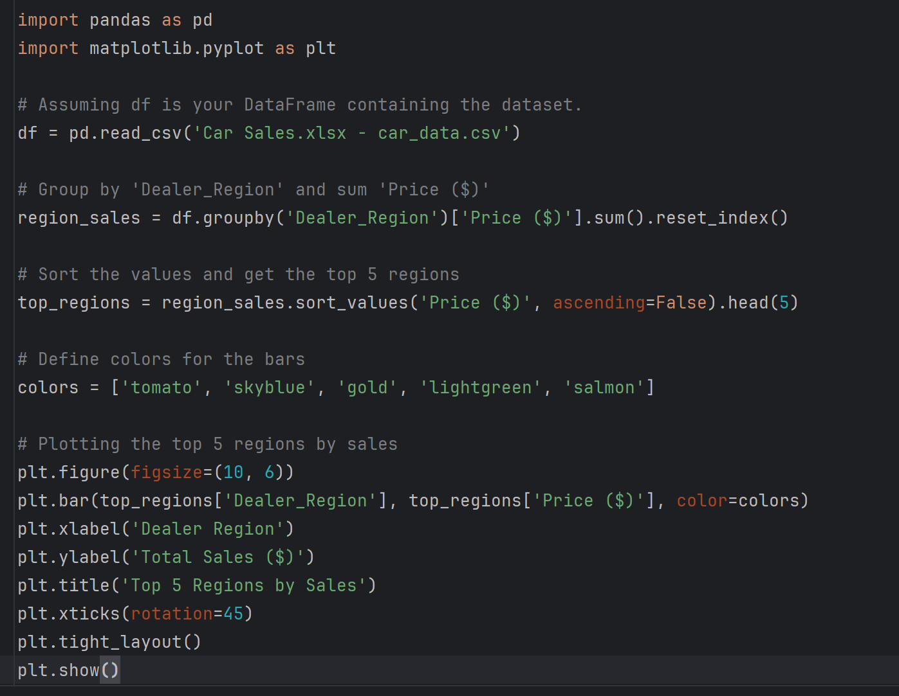

**Output**

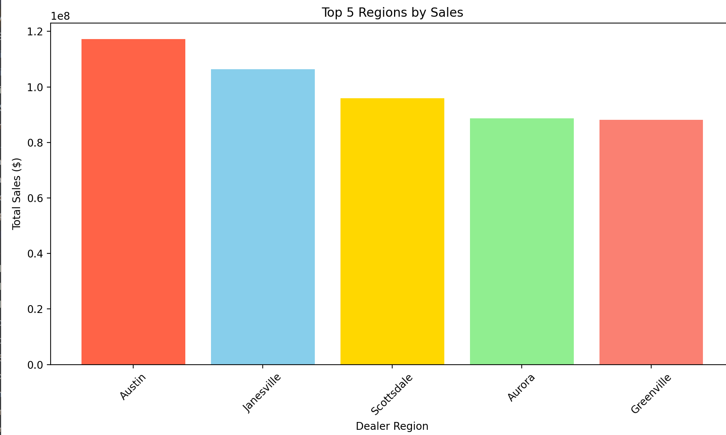

**The graph displays the total sales in dollars for the top 5 dealer regions. Austin leads with the highest sales, followed by Janesville, Scottsdale, Aurora, and Greenville, in descending order of sales performance. Each region is represented by a colored bar, indicating the magnitude of sales in that particular area.**

**8)** **Distribution of Annual Income**

**Code**

import pandas as pd

import matplotlib.pyplot as plt

# Assuming 'df' is your DataFrame containing the dataset.

df = pd.read_csv('Car Sales.xlsx - car_data.csv')

# Plotting the distribution of Annual Income

plt.figure(figsize=(10, 6))

plt.hist(df['Annual Income'], bins=30, color='skyblue', edgecolor='black')

plt.title('Distribution of Annual Income')

plt.xlabel('Annual Income ($)')

plt.ylabel('Frequency')

plt.show()

**Output**

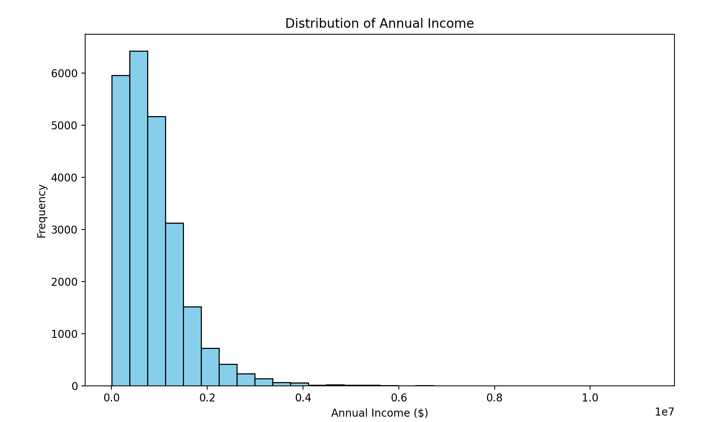

**The histogram illustrates the distribution of annual income among a group of individuals or entities. Most of the data points fall within the lower income brackets, indicating a high frequency of lower annual incomes. The frequency decreases significantly as income increases, suggesting that higher annual incomes are less common among this population.**

**9) Distribution of Car Prices**

**Code**

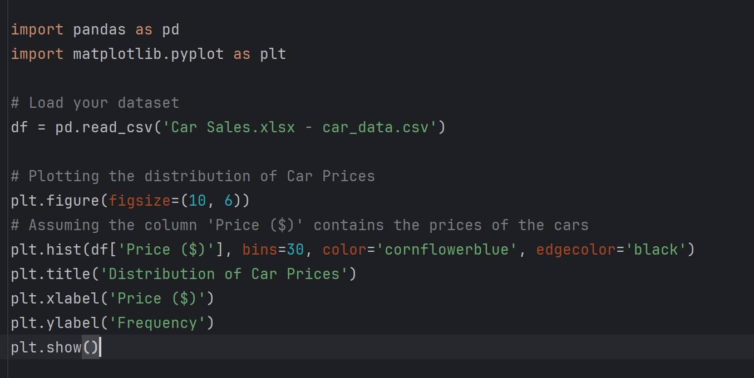

**Output**

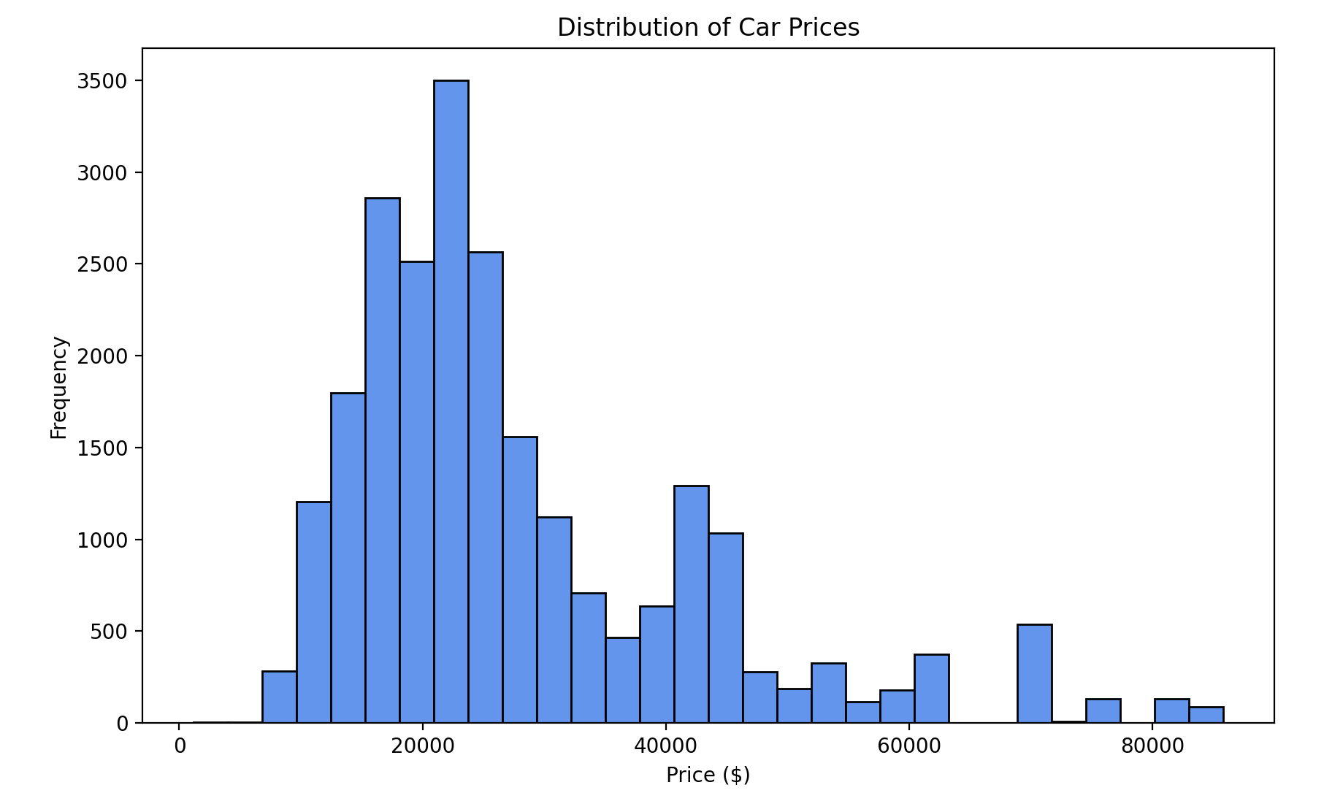

**The histogram depicts the frequency distribution of car prices. It shows that most cars are priced between $10,000 and $30,000, with the highest frequency in the $20,000 range. There are fewer cars priced above this range, indicating that higher-priced cars are less common in this dataset.**

**10) Price Distribution Across Body Style**

**Code  
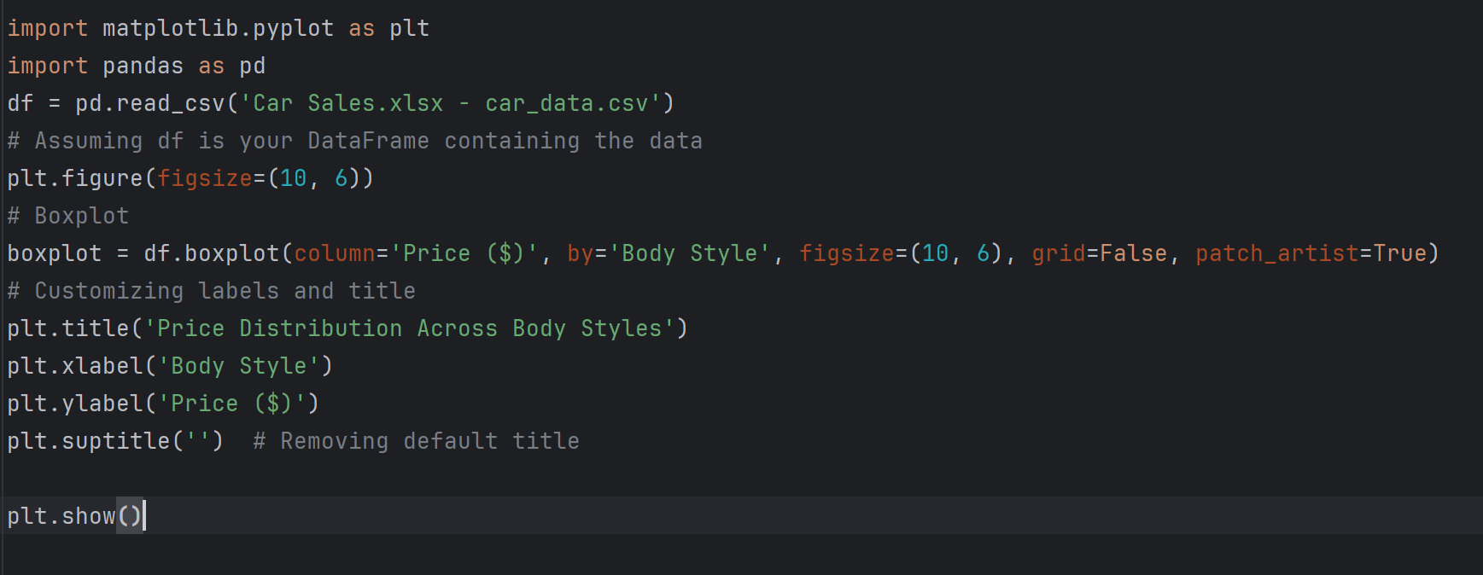**

**Output**

**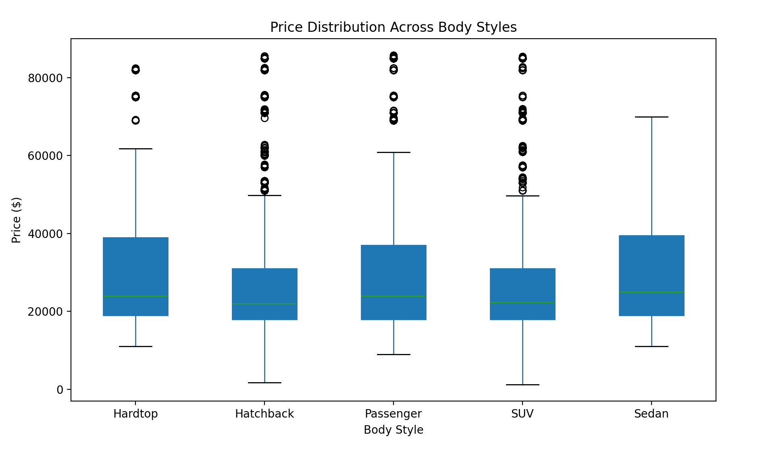  
The boxplot visualizes the price distribution across different car body styles. The variation in prices within each category is represented by the spread of the boxes and whiskers, with dots indicating outliers. It suggests that hardtop and SUV body styles tend to have a higher price range, while hatchbacks, passengers, and sedans are generally less expensive.**

**Summary**

The car sales dataset includes a comprehensive analysis of global car sales trends with 23,906 unique records. Below are the key findings and techniques used in analyzing the data:

**Data Wrangling:**

**Duplicate Records:** No duplicate entries were found, indicating a clean dataset without repetition.

**Data Type Conversion:** The 'Date' column datatype was successfully converted from 'object' to 'datetime'.

**Null Values:** Only one null value was identified in the 'Customer Name' column.

Outlier Detection and Removal: Outlier detection was performed on the 'Price' and 'Annual Income' columns with subsequent removal of identified outliers, ensuring the dataset's integrity.

**Data Mining:**

**Correlation Analysis**: A weak positive correlation (0.012) was found between 'Annual Income' and 'Price', suggesting a negligible relationship.

**Linear Regression for Profit Prediction:** The model showed poor performance with a negative R-squared score, indicating ineffectiveness in predicting car prices.

**Price Classification using Logistic Regression:** Achieved 68.28% accuracy, predominantly predicting cars as 'low' priced, highlighting a model bias.

**K-Means Clustering:** The optimal clustering was identified with five clusters, with a silhouette coefficient of 0.628 indicating well-defined clusters.

**Support Vector Machine (SVM):** Both the regression (SVR) and classification (SVC) models performed poorly, suggesting the need for model re-evaluation or feature reengineering.

**Principal Component Analysis (PCA):** Both with and without PCA, the Linear Regression models performed poorly, demonstrating no significant predictive power.

**Data Visualization:**

**Pricing Distribution:** A histogram displayed a relatively even distribution of car prices across various ranges.

**Annual Income by Dealer Region:** A bar chart on a logarithmic scale showed significant income disparities across regions.

**Car Price Trends Over Time:** A line chart depicted fluctuating car prices over the studied period.

**Customer Gender Distribution:** A pie chart revealed a predominant percentage of male customers compared to female.

**Sales Analysis by Region:** Highlighted top-performing regions in car sales through a bar chart.

**Body Style Price Distribution:** A boxplot showcased the variation in car prices across different body styles, indicating higher prices for SUVs and hardtops compared to other styles.

This comprehensive analysis provides valuable insights into market trends, consumer behavior, and the overall dynamics of the car sales industry, which can guide future business strategies and decisions.

**Link of the dataset:**

<https://www.kaggle.com/datasets/missionjee/car-sales-report/data>